**Redback Operations**

**IoT Sensor Research and Development Team**

**By**

**Sharni Sujatha**

**(Leader of IoT Sensor Research and Development Team)**

**Sensors for collecting Environment data**

**Temperature Sensor**

It is used to detect a temperature, measure the temperature and convert the temperature into electrical signal. Since different application of temperature sensor have different sensing need therefore there are various kinds of temperature sensors like thermocouples, RTDs, thermistors and integrated circuits based on semiconductors.

* Thermocouples – self powered, no excitation required, wide range of temp covered, quick response time, based on Seebeck Effect, K type is the most common, cons: small output voltage, needs precise amplification, cold junction compensation.
* RTDs – based on change in resistance, is a resistor, most common material – platinum to make it = PRTDs with resistance between 100 to 1000 ohms at 0 degree C, have high thermal mass, excitation current needed, slow response. Four wire is the most accurate – no wire resistance. MAX31865.
* Thermistors – made of polymer or ceramic, less accurate, NTC thermistors are most common, resistance decreases with rise in temp.
* Integrated Circuits based semiconductors, two types: local temp sensor and remote digital temp sensor, local – own die temp measured – physical property of transistor- analog or digital signals- temp of surrounding air or circuit boards - MAX31875, remote – temp of external transistor- transistor away from sensor chip

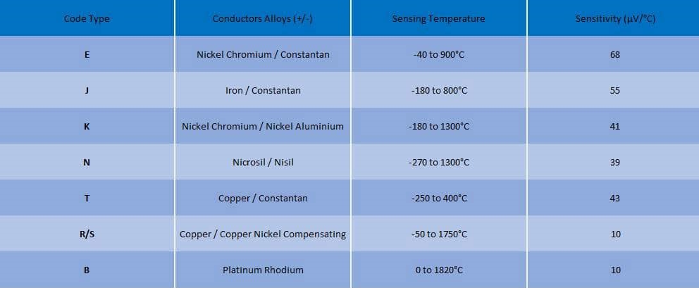

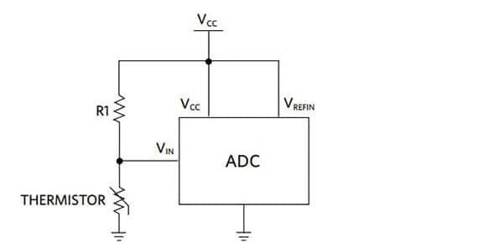

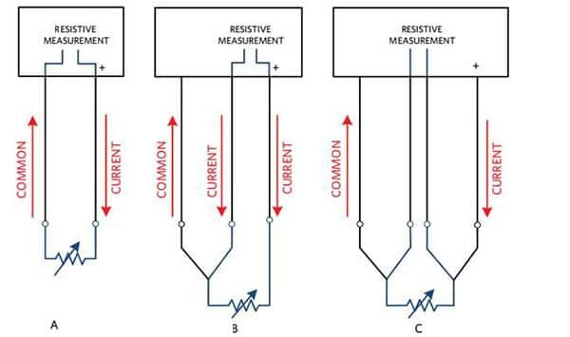

**Humidity Sensor**

It is used to detect and measure water vapor. Measures dew point and absolute humidity, relative humidity and temperature, detects alteration in electric current or temp in the air, There are three types: capacitive, resistive and thermal.

* Capacitive
* relative humidity
* thin strip of metal oxide between two electrodes
* electrical capacity changes with relative humidity
* provide stable reading
* wide range of data covered
* limited by distance between sensor and signalling circuit.
* Resistive
* ions in salts
* measure electrical impedance
* electrical conductivity sensor
* low-cost devices
* interchangeable
* function in remote monitoring situations
* Thermal
* absolute humidity
* difference in thermal conductivity
* usable in high temperature
* durable
* higher resolution

Different Humidity sensors:

<https://au.element14.com/c/semiconductors-ics/ic-sensors/humidity-sensors>

**Air Quality Sensor**

Measures the attenuation of infrared radiation in the air.

Particle sensors could be a better alternative.

* measure airborne particles
* less accurate than particle monitors
* light scattering techniques
* calculate particle concentration

<https://www.epa.vic.gov.au/-/media/epa/files/publications/1745.pdf>

**Barometric Altimeter Sensor**

Altimeter is used to measure the altitude. Two main types: pressure altimeter and radio altimeter.

Barometric Altimeter Senor

* atmospheric pressure
* measured on barometric scale
* all changes will be considered due to weather and changes in ambient pressure
* determine changes in elevation too
* not preferred if there are frequent elevation changes

**GPS Sensor**

* satellite based tech
* receivers with antennas
* RF frequency
* speed, position and timing.
* 4 or more satellites more accurate data

<https://www.seeedstudio.com/blog/2019/11/06/arduino-gps-modules-which-one-to-use-guide-and-comparisons/>

**Sensors for Collecting Health Data**

**Body Temperature Sensor**

IR temperature sensor

* accurate no contact sensing
* thermocouples on silicon chip

Digital temperature sensor

* accurate measurement with digital output
* small circuit board package

<https://www.heimannsensor.com/body-temperature>

[Arduino Based Digital Thermometer using MAX30205 Human Body Temperature Sensor (circuitdigest.com)](https://circuitdigest.com/microcontroller-projects/arduino-max30205-human-body-temperature-measurement)

**Heartrate Sensor**

* Tracks heart rate in real time
* Use of fully automated algorithms

Pulse Sensor

* optical
* light-based tech
* measures the pulse
* can also measure blood oxygen saturation
* photoplethysmography
* more convenient
* more inaccurate

ECG sensor

* chest strap
* heartbeat detected radio signal transmitted
* monitor and transmitter
* electrocardiography
* more accurate
* lesser human error
* lesser flexible

**Sensors for collecting Body Motion data**

**Gyroscope**

* senses angular velocity
* vibration sensors used
* Coriolis forced force applied
* also called rate sensors
* provide stability and direction
* movement of sensing arm determines the angular velocity

6-axis gyroscope

* 3-axis gyroscope (roll, yaw and pitch)
* 3 axis accelerometers
* Flex Sensor

**Sensors for collecting Bicycle Data**

* Cadence Sensors (separate document)
* Speed Sensors (separate document)

**Fact Sheets:**

Particle Sensor:

<https://www.epa.vic.gov.au/-/media/epa/files/publications/1745.pdf>

**Reference**:

Temperature Sensor:

<https://www.digikey.com.au/en/blog/types-of-temperature-sensors#:~:text=There%20are%20four%20types%20of,based%20integrated%20circuits%20(IC>).

Humidity Sensor:

<https://www.te.com/usa-en/products/sensors/humidity-sensors.html#:~:text=A%20humidity%20sensor%20is%20a,products%20to%20measure%20relative%20humidity>.

<https://canada.newark.com/sensor-humidity-sensor-technology#:~:text=There%20are%20three%20basic%20types,metal%20oxide%20between%20two%20electrodes>.

<https://www.linquip.com/blog/types-of-humidity-sensors/>

Barometric Altimeter Sensor:

<https://www.britannica.com/technology/altimeter>

<https://www.correrunamaraton.com/en/gps-altimeter-barometer/> - recommended

Body temperature Sensor:

<https://www.te.com/usa-en/trends/connected-life-health-tech/medical-sensor-technology-and-applications/body-temperature-measurement.html#:~:text=Infrared%20(IR)%20temperature%20sensors%20enable,forehead%20temperature%2C%20or%20skin%20temperature>.

Heart rate sensor:

<https://arstechnica.com/gadgets/2017/04/how-wearable-heart-rate-monitors-work-and-which-is-best-for-you/#:~:text=Heart%2Drate%20monitoring%20chest%20straps,and%20a%20snap%2Don%20transmitter>.

<https://www.verywellfit.com/heart-rate-monitor-3436583>

<https://www.dfrobot.com/product-1540.html>

<https://au.wahoofitness.com/devices/heart-rate-monitors>

<https://health.clevelandclinic.org/serious-about-your-workouts-get-a-heart-rate-monitor/>

<https://au.pcmag.com/heart-rate-monitors/46910/the-best-heart-rate-monitors>

<https://create.arduino.cc/projecthub/Ingeimaks/diy-heart-rate-sensor-a96e89>

<https://lastminuteengineers.com/pulse-sensor-arduino-tutorial/>